RINGS-A000-EUR-Italy-Rome- Leg I Parthica

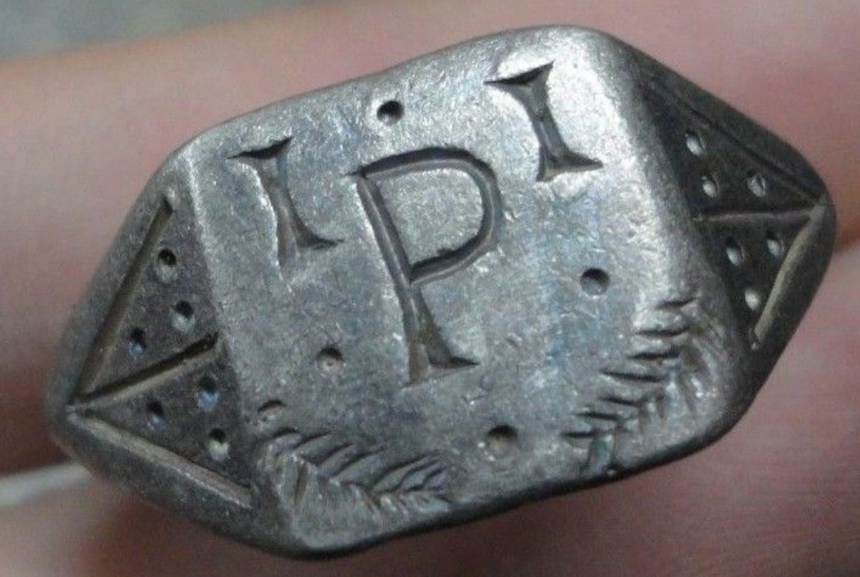 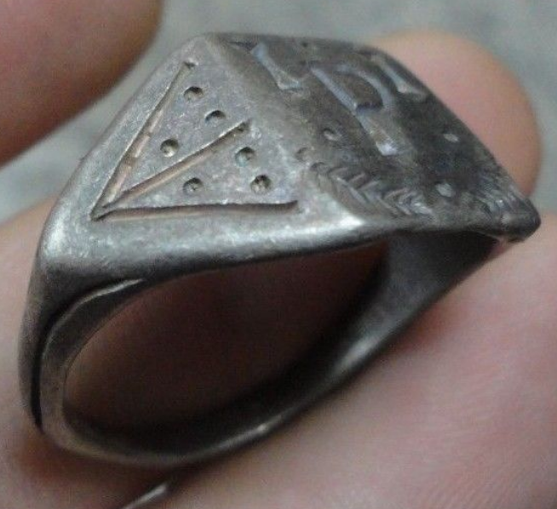 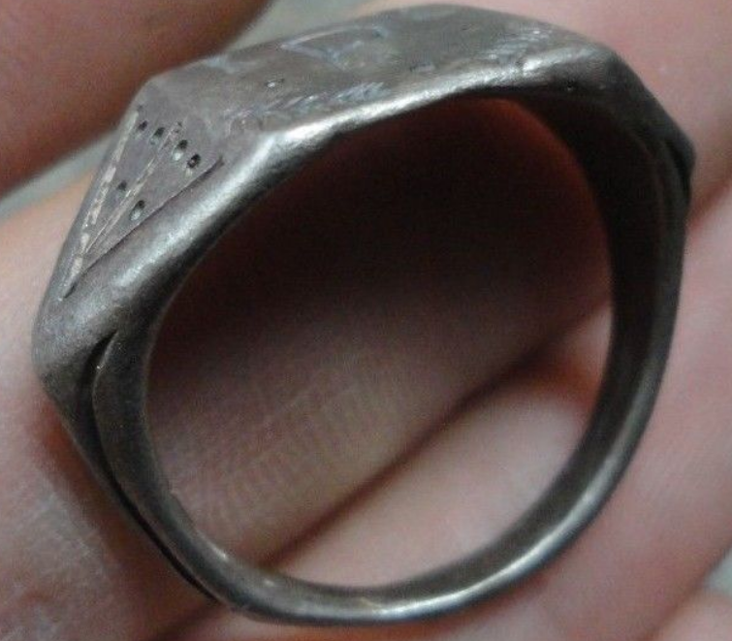 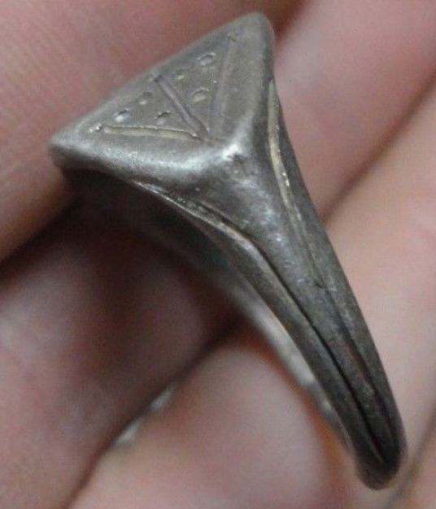 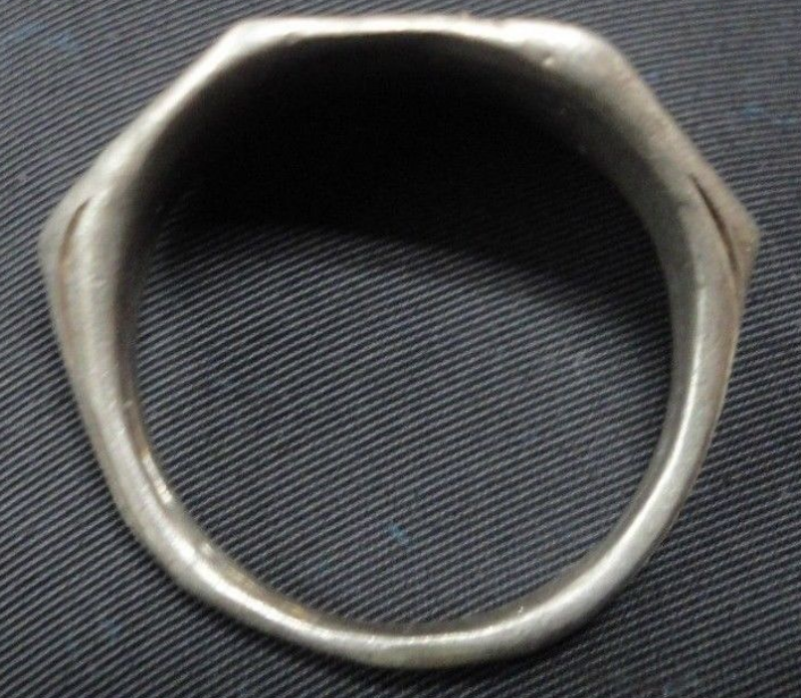

**Legio I Parthica**

**Legio prima Parthica (Latin for "1st Parthian Legion") was a legion of the Imperial Roman army founded in AD 197 by the emperor Septimius Severus (r. 193-211) for his forthcoming war against Parthia. The legion's presence in the Middle East is recorded until the early 5th century. The legions I, II, and III Parthica were levied by Septimius Severus for his campaign against the Parthian Empire. After the success of this campaign, I and III Parthica remained in the region, in the camp of Singara (Sinjar, Iraq), in Mesopotamia, to prevent subsequent rebellions and to guard the eastern provinces from attacks from the Parthian Empire. Legionaries from I Parthica were usually sent to other provinces, namely Lycia, Cilicia and Cyrenaica. In 360, I Parthica unsuccessfully defended its camp against a Sassanid attack; after the defeat, the legion was moved to Nisibis (modern Turkey), where it remained until the city was surrendered to the Sassanid Persians in 363. After that, the legion was moved to Constantina, where it is last mentioned in the 5th century.**

INSCRIBED - " P - I "

EXTREMELY RARE **Roman SENATORIAL LEGIONARY SILVER ring.**

SOLID SILVER - Wearable <> 9.00 grams <>

**<> 21.50mm. = 0.86" Inner diameter <>**

Silver, I purchased this item as an ancient Roman relic but have no papers with the item, so bid a